**LAWN SPRINKLER AUTOMATION**

Statement of the problem:

* Can we automatically water the plants when we are going out on vacation or do we need to bother our neighbours?
* Plants are precious and sensitive creations that may get destroyed by lack of water as well as by excess of it. Water affects their growth and production. So how do we really know if the soil needs to be watered?
* Water is a significant resource that needs to be saved. By monitoring certain conditions can we control the amount of water fed to our lawns to omit wastage?
* Can we save time on manual irrigation and reduce manual labour?
* Can we manually water the plants at the click of a button?

Why is the topic chosen?

* This project not only **saves water** but also provides the **optimum amount of moisture** for plants to grow.
* It can be implemented in household lawns to provide **convenience** of automated water irrigation.

Objective and scope of the project:

* The primary objective of the project is to minimize water wastage.
* Moreover, it will be a help to not only the farmers but also to the people who love a garden in their backyard.
* It will facilitate the agricultural industry and save time and money wasted on manual labour.

Methodology:

Irrigation automation using Arduino is a prototype of how we can automate the agricultural industry for watering the plantation. The automated irrigation will be done based on the Arduino microcontroller integrated with the temperature, humidity and moisture sensors.

Once the sensors conclude that the water level is low in the soil and the temperature is getting high, with certain feasible algorithms, it will send a signal to the Arduino, which will activate the water pump.

A smartphone might also come in handy in case you want to receive notification and want to water the plants at the push of a digital button.

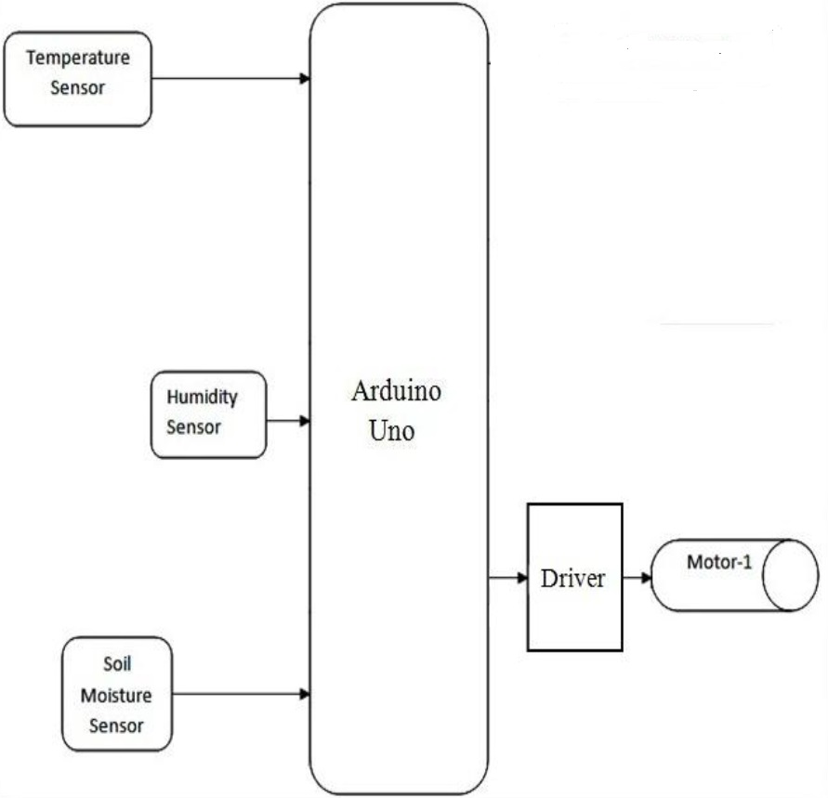

**BLOCK DIAGRAM**

Hardware Needed:

* **Arduino**

Arduino board designs use a variety of microprocessors and controllers. The boards are equipped with sets of digital and analog input/output (I/O) pins that may be interfaced to various expansion boards and other circuits. The boards feature serial communications interfaces, including Universal Serial Bus (USB) on some models. The microcontrollers are typically programmed using a dialect of features from the programming languages C and C++.

* **Soil moisture sensor**

Soil moisture sensors measure the volumetric water content in soil.

* **Temperature and humidity sensor**

It features a temperature & humidity sensor complex with a calibrated digital signal output. By using the exclusive digital-signal-acquisition technique and temperature & humidity sensing technology, it ensures high reliability and excellent long-term stability. This sensor includes a resistive-type humidity measurement component and an NTC temperature measurement component offering excellent quality, fast response, anti-interference ability and cost-effectiveness.

* **Water pump**

DC 3-6V Micro Submersible Mini Water Pump

* **Pump controller**

It is a small circuit made of transistor and resistor connected to motor and Arduino.

* **Transistor**

A transistor is a semiconductor device used to amplify or switch electronic signals and electrical power. It is composed of semiconductor material usually with at least three terminals for connection to an external circuit.

* **Resister**

A resistor is a passive two-terminal electrical component that implements electrical resistance as a circuit element. In electronic circuits, resistors are used to reduce current flow, adjust signal levels, to divide voltages, bias active elements, and terminate transmission lines.

* **Drip irrigation kit (feeder, connection pipe)**

Used to connect pump to plant to supply water from feeder.

* **Jumper cables and wires**

used for making connections.

* **Breadboard and LED’s**
* **Smartphone/Laptop**

Software Needed:

* Arduino IDE
* Android studio

Testing technology used:

What contribution would your project make?

* Our project is a prototype and it’s full-scale model can be used the University Campus Lawns.
* In near future this can be implemented in household lawns and backyards to provide convenience of automated watering.
* This automation could also be utilised for industrial purposes like in green houses.
* It saves various crucial resources such as water, time and money.
* Moreover, an **Internet of Plants** can be woven in which plants can share data amongst each other. For further studies the data about various plants/crops can be collected in a single database, accessible for all.